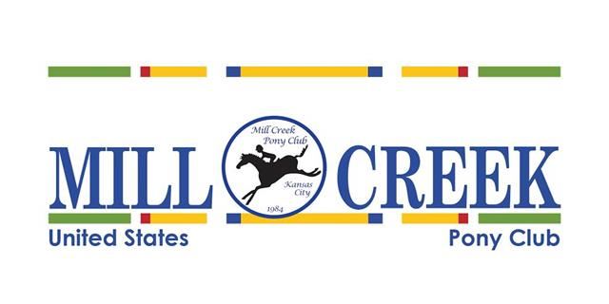

To Whom it May Concern :

Mill Creek Pony Club is proud to announce our annual MCPC Horse Trials at Longview Horse Park in May.

This is the main fund-raising event for Mill Creek Pony Club’s educational activities for children and we would appreciate your support!

There are many ways you can support Mill Creek Pony club and create valuable promotional impact to your business.

Support levels:

* Sponsorship has multiple levels which includes Vendor booth, Company Mentions, Company Fliers, Ad Program, Posted Company Sign. Please contact us for more information.
* Advertising in Program great way to promote your products and services to a target loyal group of potential clients and support a great event.
* In-Kind and Prize Donations allow our club to offer great packets and prizes which gives you to directly help us make this an amazing event while promoting your business.

Mill Creek Pony Club is a local club devoted to children and horses. Pony Club is the largest equestrian educational organization in the world.  This is where it all begins! The cornerstones of our foundation are education, safety, sportsmanship, stewardship and FUN. Members learn riding and the care of horses through mounted sports. The skills, habits and values instilled through horsemanship will apply to every part of a member’s life.

The Mill Creek Pony Club- <https://millcreek.ponyclub.org/contact/>

All adult leaders in Pony Club are volunteers so that all fund raising efforts go directly to benefit the children’s equestrian activities. The Pony Club is a non-profit, IRS 501 (c)(3) tax-exempt organization, so all donations are acknowledged with a receipt signifying the donation as such.